**Aaron OBryant**

**CMSC 307 7380**

**11/27/2022**

**After logging into the AWS Console, I navigated to the Amazon Rekognition tool as shown in figure 1 and figure 2.**

**Figure 1. Successful login into AWS Console**

**Figure 2. Navigated successfully to Amazon Rekognition**

**The Amazon Rekognition tool is used to identify people, places, or things in images. By uploading certain pictures, the program will point out specific details such as glasses, a boat, or a building. After categorizing certain parts of the image, Rekognition then gives a percentage of how confident it is that its identification is correct. Figure 3 shows the splash page for one of the subpages for Amazon Rekognition and that is label detection. Label detection is the main tool used to label objects, scenes and actions as stated before.**

**Figure 3. Navigated to label detection in Amazon Rekognition**

**I experimented with label detection three times in Amazon Rekognition, and I can honestly say that I am pleased with the results. In Figure 1, I researched an image of a HBCU’s Homecoming and uploaded into label detection. A detailed report identified many objects or people in this illustration which includes a man and an adult.**

**Figure 4. First upload and detection results.**

**While the program is confident in its decision with these two labels, I also found it surprising that Rekognition was almost 100% certain that this photo came from a comic. While the illustration is comic-like, it is from Levelman.com from an article named “A Toast to HBCU Homecoming, the Epicenter of Black Success.” As shown in figure 2, I uploaded a second image into the label detection tool, this time it is a photograph of popular Disney characters at Disney World. This photo better showcased the label detection’s skills and that is evident by the confidence ratings given to the identifications. With 96.4% confidence, Rekognition identified “Theme Park” and “Amusement Park.” I was also surprised when the program identified “Fun” in the photo even though the word “Fun” is not present. It amazed me how Rekognition could discern the mood of a photo with near perfect accuracy.**

**Figure 5. Second upload and detection results.**

**I uploaded a final photo into the label detection tool and this time it is the movie poster for “Harry Potter and the Sorcerer’s Stone.” As shown in figure 6, the close accuracy almost mimics the previous image’s report. I am still surprised that the tool determined that my photo is an advertisement with 99.9% confidence. Not only that but with 99.8% confidence label detection believed that the poster is a book. As many know, “Harry Potter and the Sorcerer’s Stone” is a movie based on the book of the same name.**

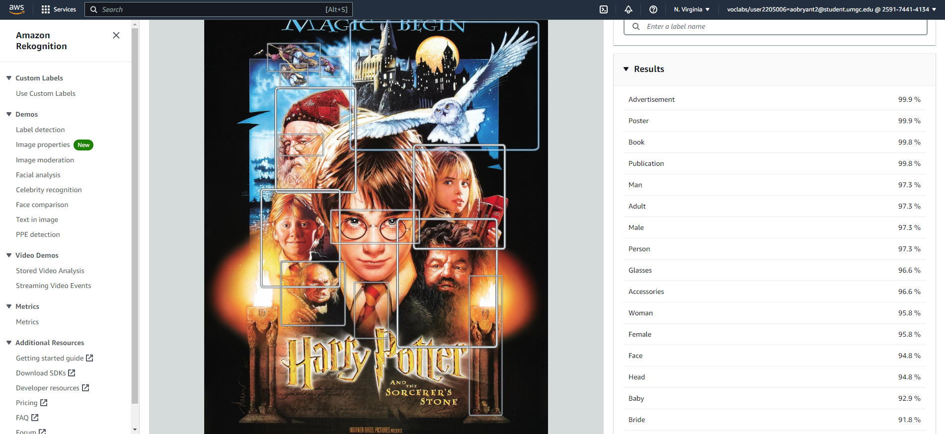

**Figure 6. Third upload and detection results.**

**Amazon Rekognition also has a celebrity recognition feature where I can upload an image of a celebrity and the system identifies that person. First, I uploaded a picture of Nipsey Hussle in the tool and he was correctly identified as shown in figure 7. Figure 8 shows the results of my upload of Chadwick Boseman into the system and with 99% confidence he was identified. The same trend persisted in figure 9 where a photo of J. Cole was identified.**

**Figure 7. Nipsey Hussle correctly recognized.**

**Figure 8. Chadwick Boseman correctly recognized.**

**Figure 9. J. Cole correctly recognized.**

**Amazon Rekognition gives a glimpse of what computer vision AI really is and how it is used. Computer vision is a field of study in AI where cameras are used to identify persons of interest. These persons could be victims of crimes or suspects and they are identified by physical characteristics. These characteristics range from their face structure to the way an individual walks. Computer vision can be used in many arenas to assist human work and make life a little more convenient. For example, Google Translator uses computer vision to translate signage from its native language to the user’s preferred language (IBM). This is possible when a user uses their camera to take a photo of a sign and uploads the picture into the application. In the Entertainment realm, computer vision was used to clip together highlights of the 2018 Masters golf tournament. To do this, IBM’s Watson watched hours of the tournament and identified reaction sounds of spectacular shots and clipped them together.**

**References**

* **Bucolo, D. (2021, March 23). *Pros and cons of visiting Disney world in 2021*. EatSleepCruise.com.**[**https://eatsleepcruise.com/visiting-walt-disney-world-in-2021/**](https://eatsleepcruise.com/visiting-walt-disney-world-in-2021/)
* **Griffith, J. (2020, August 29). Hollywood remembers Chadwick Boseman as 'superstar on screen and in life'. NBC News. https://www.nbcnews.com/pop-culture/celebrity/hollywood-remembers-chadwick-boseman-superstar-screen-life-n1238779**
* **IBM. (n.d.). *What is computer vision?* https://www.ibm.com/topics/computer-vision**
* **IMDb. (2001, November 16). *Harry Potter and the sorcerer's stone (2001)*.**[**https://www.imdb.com/title/tt0241527/**](https://www.imdb.com/title/tt0241527/)
* **IMDb. (n.d.). *J. Cole*. https://www.imdb.com/name/nm3359577/**
* **IMDb. (n.d.). *Nipsey Hussle*. https://www.imdb.com/name/nm2596169/**
* **LEVEL Man. (2022, October 24). *A toast to HBCU homecoming, the epicenter of Black success*.**[**https://www.levelman.com/hbcu-homecoming-epicenter-black-success/**](https://www.levelman.com/hbcu-homecoming-epicenter-black-success/)